**Steps to enter in different local disk from C:**

*type space 'cd' space copy *address of the desired folder* press enter.

*type *desired local folder* say 'E:'

*type space "jupyter notebook"

**Code for mark sheet**

**CODING:**

for e in range(30):

print("*", end="")

print("marksheet", end="")

for e in range(30):

print("*", end="")

subjects = []

marks = []

total_marks_per_subject = []

no_of_subjects = int(input("\nEnter number of subjects "))

for i in range (no_of_subjects):

sub = input("Enter subject ")

subjects.append(sub)

mark = int(input(" Enter gain marks (between 0-100) ")) #print(end = "")

marks.append(mark)

total_mark = int(input(" Out of "))

total_marks_per_subject.append(total_mark)

marks_gained = sum(marks)

total_marks = sum(total_marks_per_subject)

print("\n")

for c in range(35):

print("*" ,end="")

print("\n%-25s %s" %("subjects", "marks"))

if(no_of_subjects >= 1):

print("%-25s %s" %(subjects[0], marks[0]))

if(no_of_subjects >= 2):

print("%-25s %s" %(subjects[1], marks[1]))

if(no_of_subjects >= 3):

print("%-25s %s" %(subjects[2], marks[2]))

if(no_of_subjects >= 4):

print("%-25s %s" %(subjects[3], marks[3]))

if(no_of_subjects >= 5):

print("%-25s %s" %(subjects[4], marks[4]))

if(no_of_subjects >= 6):

print("%-25s %s" %(subjects[5], marks[5]))

if(no_of_subjects >= 7):

print("%-25s %s" %(subjects[6], marks[6]))

if(no_of_subjects >= 8):

print("%-25s %s" %(subjects[7], marks[7]))

if(no_of_subjects >= 9):

print("%-25s %s" %(subjects[8], marks[8]))

if(no_of_subjects >= 10):

print("%-25s %s" %(subjects[9], marks[9]))

if(no_of_subjects >= 11):

print("%-25s %s" %(subjects[10], marks[10]))

if(no_of_subjects >= 12):

print("%-25s %s" %(subjects[11], marks[11]))

if(no_of_subjects >= 13):

print("%-25s %s" %(subjects[12], marks[12]))

print("\n")

for c in range(35):

print("*" ,end="")

student = input("\nEnter student name ")

print("\nThe total marks obtained by " + student + " are ", end = "" )

print(marks_gained)

percentage = (marks_gained/total_marks)*100

print("\n" + student + " has got the percentage ", end = "" )

print(percentage, end="")

if percentage >= 80:

print(" with grade A+", end ="")

elif percentage >= 70:

print(" with grade A", end ="")

elif percentage >= 60:

print(" with grade B", end ="")

elif percentage >= 50:

print(" with grade C", end ="")

elif percentage >= 40:

print(" with grade D", end ="")

elif percentage < 40:

print(" and you are fail ", end ="")

**OUTPUT:**

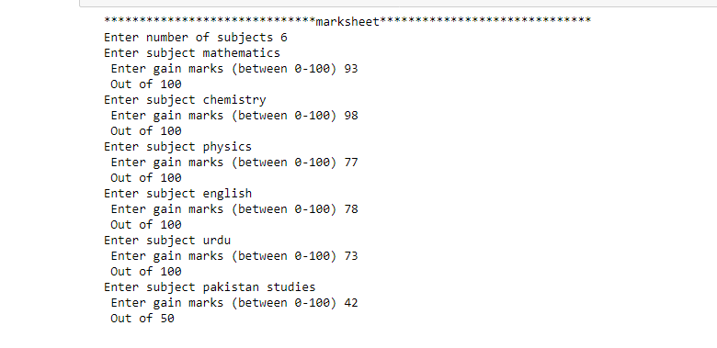

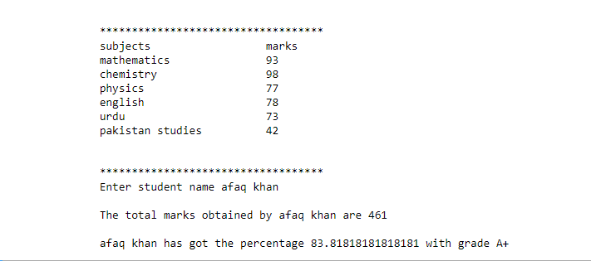

**Notes to remember:**

File name in **github** for **jupyter notebook** is *name of file.***ipynb**